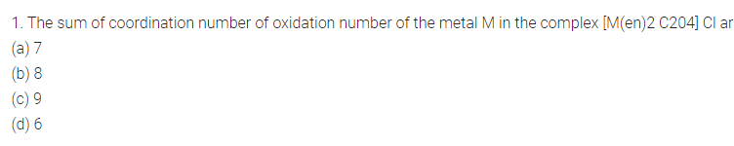

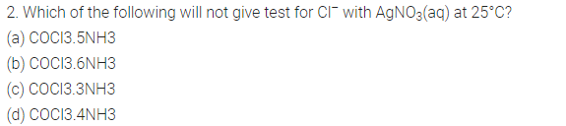
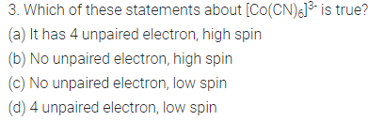
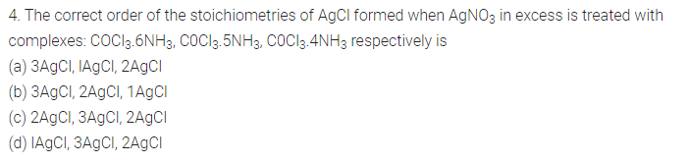
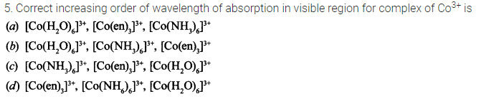
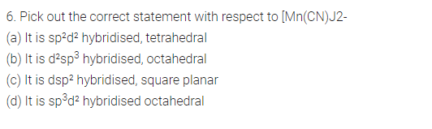
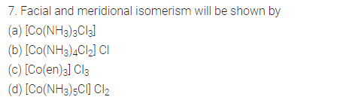
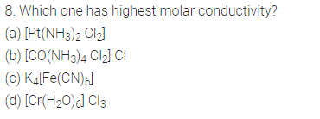
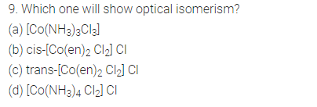
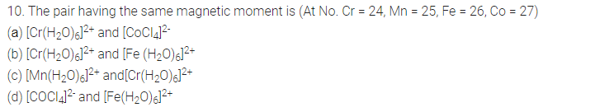
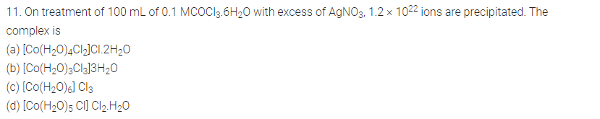
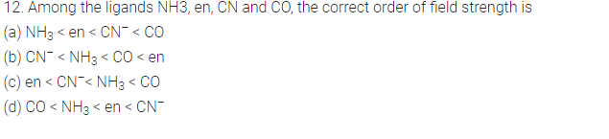
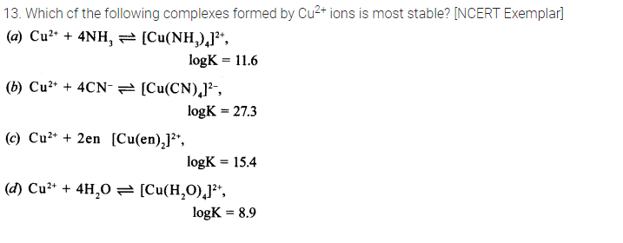
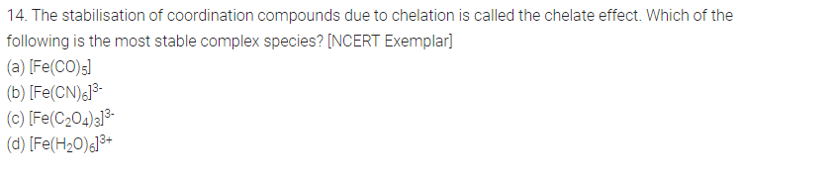
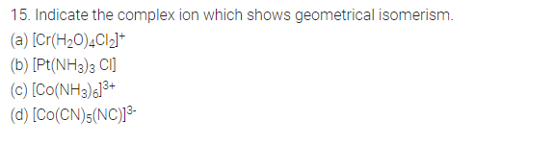
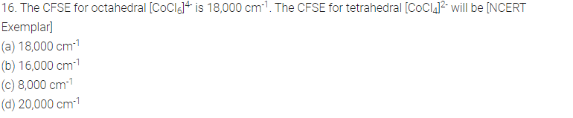
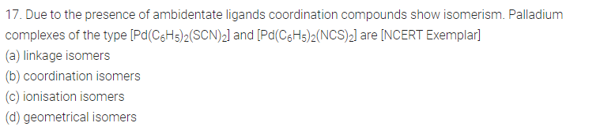
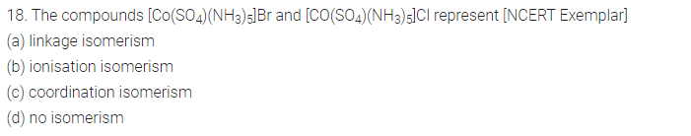
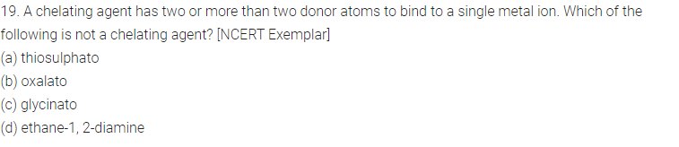
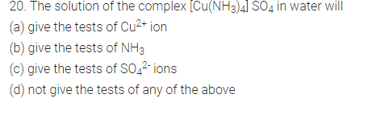
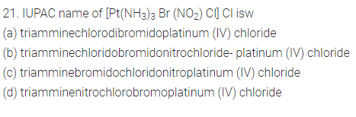
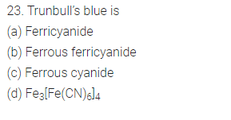

24. When 1 mole of CrCl₃.6H₂O is treated with excess of AgNO₃, 3 moles of AgCl are obtained. The formula of the complex is
(a) [CrCl₃(H₂O)₃].3H₂O (b) CrCl₂(H₂O)₄]Cl.2H₂O
(c) [CrCl(H₂O)₅]Cl₂.H₂O (d) [Cr(H₂O)₆]Cl₃
25. Atomic numbers of Mn, Fe and Co are 25, 26 and 27 respectively. 2. Which of the following inner orbital octahedral complex ions are diamagnetic?
(i) [Co(NH3)6]3⁺
(ii)[Mn(CN)6]3⁻
(iii) [Fe(CN)6]4⁻
(iv) [Fe(CN)6]³⁻
- i and ii
- ii and iii
- iand iii
- iv and iii
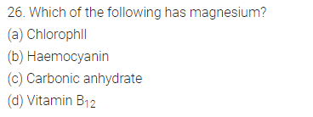
27. Predict the number of ions produced per formula unit in an aqueous solution
of [Co(en)3]Cl3
(a) 4
(b) 3
(c) 6
(d) 2

